**Python Project: Average Daily Screen Time for Children**

This Python project focuses on analyzing daily screen time data across different age groups, genders, and day types. Using libraries like Pandas and Matplotlib, I visualize patterns in digital usage that highlight trends and inform healthier screen-time practices for children.  
***Goal****:* The research aims to examine screen time distribution by age groups, gender categories, and day choices through visual representations that illustrate digital behavior tendencies leading to better lifestyle health.  
***Technology***: Python, Pandas, Matplotlib/Seaborn  
***Skills***: Data Wrangling, Data Visualization, Exploratory Data Analysis  
Explore the Complete Project here →

# **Python project: Average Daily Screen Time for Children**

Screen time has become a significant life factor due to advancements in today's digital world. The way people use screens shows significant patterns that allow all stakeholders, from the general public to educational institutions to political bodies, to develop informed decisions. A dataset on screen time serves as the basis for creating visual representations that study the relationships between age, gender, and screen time and day type effects on screen usage together with screen time type distributions.

Below is a snip of the data used

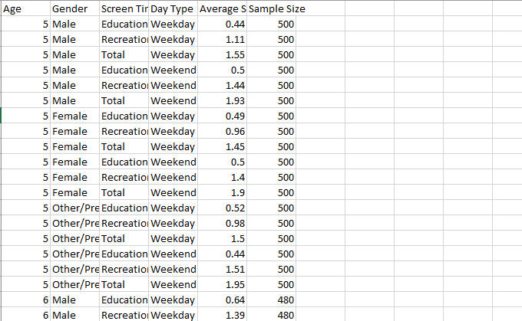

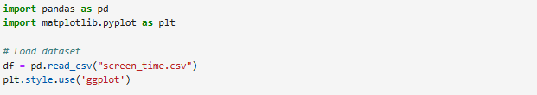

**Line Chart: Age vs. Screen Time by Gender**

The first graph, a line chart, displays an age-related line chart that shows screen time data separated by gender groups. The data shows how user screen duration changes with age and the effect of gender differences.

I grouped the data by Gender (male and female).

For each gender, I plotted Age on the x-axis and Average Screen Time (hours) on the y-axis.

I added markers ('o') to make each data point visible and labeled each gender for easy comparison

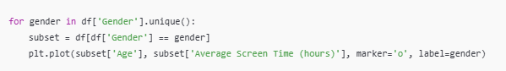

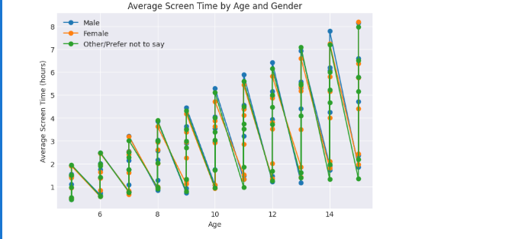

The plot demonstrates that older users spend longer amounts of time on screens, according to a constant pattern observed in both male and female participants.

**Grouped Bar Chart Screen Time Type by Day Type**

A grouped bar chart in the second graph demonstrates that screen time distribution changes between weekdays and weekends. The chart reveals which screen time activities exist across weekdays and weekends, including their separate distributions.

I separated the data into day types: 'Weekday' and 'Weekend'.

For each screen time type (Social Media, Entertainment, Work), I calculated the average screen time separately for weekdays and weekends.

I plotted these averages side-by-side (grouped bars) to allow direct comparison between weekdays and weekends.

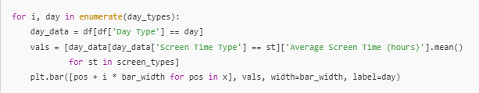

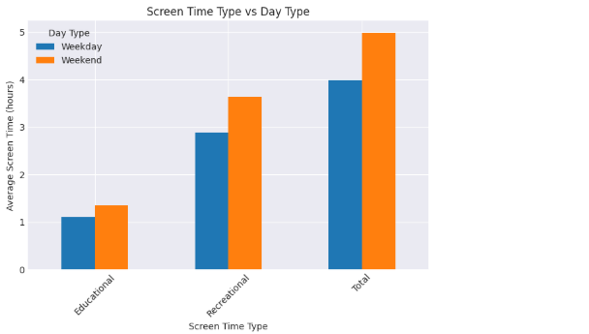

The bar chart demonstrates that users spend more time on screens during weekends while performing entertainment and social media tasks than on weekdays when they focus on work-related tasks.

**Proportion of Screen Time Types**

The third visualization displays screen time distribution through a donut plot representing different activity type proportions. This chart shows the different screen activity proportions that determine total average screen time duration through their relative contribution rates.

I grouped the data by Screen Time Type.

I calculated the average screen time for each type (Entertainment, Work, Social Media).

I plotted a pie chart, but added a "donut hole" (by setting the width=0.5 inside the pie wedges) to make it more stylish.



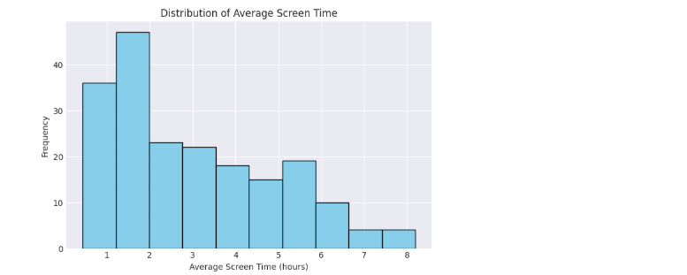

Among the different screen time categories, entertainment comprises the greatest segment, surpassing social media practices and educational and work-oriented activities.

**Screen Time by Gender & Day Type**

This fourth visualization combines stacked bars to present screen time comparisons between genders and day types. The visual presentation provides distribution data about screen time used by genders on weekdays and weekends to create more detailed insights about screen use patterns between different groups.

I grouped the data by Gender and Day Type together.

Then I calculated the average screen time for each group.

I used stacked bars, meaning for each gender, weekday and weekend screen time were stacked on top of each other.

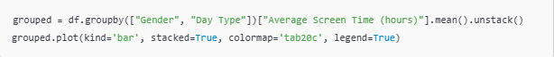

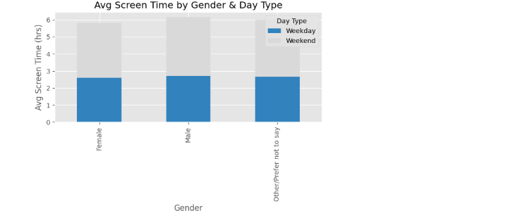

The data reveals that screen usage between men and women matches up on weekdays, yet women spend extra time on screens on weekends mainly for leisure purposes.

**Consolidation of All Visualizations**

Finally, all four visualizations are combined into a single summary figure with subplots. The figure provides an integrated dataset perspective to compare and contrast findings between all separate plots.

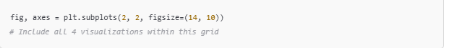

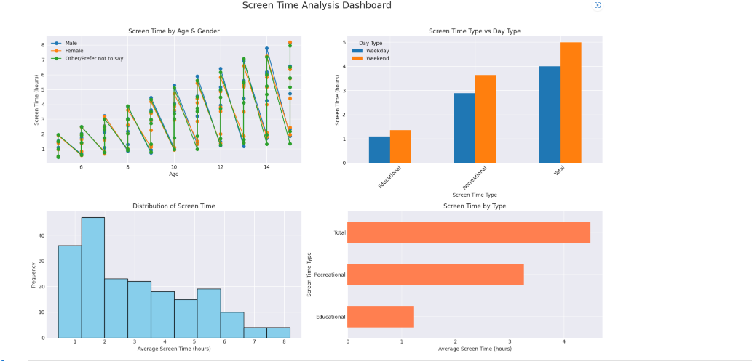

The summary figure reinforces the individual findings and makes it easy to compare the trends in screen time across various demographics and day types in one glance.

**Conclusion**

The visualizations clearly understand screen time behaviours across different age groups, genders, and day types. The line chart shows that screen time grows as an individual ages, but the grouped bar chart demonstrates that screen time reaches greater levels on weekend days. The entertaining and social media content dominates the donut chart presentation, and the stacked bar chart demonstrates gender-specific weekend screen time usage patterns. The aggregated summary figure provides an extensive data view, showing all significant findings from different charts. The evaluation provides valuable insights into human behavioural changes regarding screen time usage, which depend on population characteristics and weekly periods.